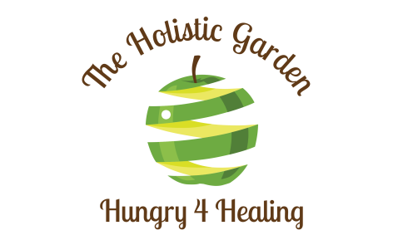

3 PEA SALAD
Compliments of The Holistic Garden

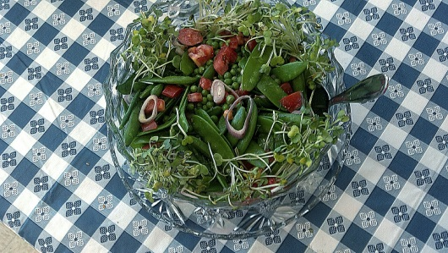

Serves 8-10, as a side salad

Salad Greens

2 cups snap sugar peas, ends trimmed then sliced on the diagonal
1 cup fresh(not frozen)garden peas, raw. If you can’t tolerate raw, blanch before tossing into the salad.
2 shallots, sliced into rings
4 diced roma(plum) tomatoes
3 cups pea shoots or micro greens

Add the above ingredients to a bowl. A clear glass serving bowl is ideal to serve this salad in because you want to showcase all the beautiful textures and colors.

Lemon/Dijon Dressing

1/3 cup fresh squeezed lemon juice
1 teaspoon Dijon Mustard(later freshly grated horseradish is tossed into the salad)
OR
Trader Joe Garlic Aioli Mustard which has a sharpness like horseradish root that plays off of the Microgreens nicely.
1 teaspoon honey
½ teaspoon salt
¼ teaspoon black pepper
1 smashed garlic clove
Place above ingredients in a glass jar with a good lid….shake.
Then add
1/3 cup Extra virgin olive oil. Shake again.
Making this a day ahead allows the garlic to infuse into the dressing.

Dress the salad, then add freshly grated horseradish root, toss and enjoy

