PEACH and HEIRLOOM TOMATO PANZANELLA SALAD
Compliments of The Holistic Garden

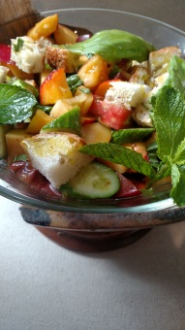

Peaches and heirloom tomatoes are in season at roughly the same time so why not incorporate these 2 juicy fruits into a Panzanella Salad that can absorb their natural flavors into the rustic bread cubes.

Bread:

Cube up day old baguette or French bread into about 1 inch cubes. Spread out onto a sheet tray in a low oven(250 degree) until bread is dried out somewhat.

If the bread is hearty like a sour dough…you can skip the above step

Dressing:

Pour the following ingredients into a 1 cup measuring cup

¼ cup white balsamic vinegar
Balsamic vinegar is made from fruit so goes well with fruit salad and
We should all know that tomato is a fruit
Enough fresh squeezed lemon and orange to bring the liquid up to the
Half cup mark
Add salt and pepper, then whisk till salt is dissolved
Add 1 teaspoon each of good quality honey & Dijon mustard and whisk again
Now pour enough extra virgin olive oil to equal the other ingredients in the measuring cup.
You will see the line of demarcation because oil and vinegar don’t mix.
You want equal parts fat and acid here.
Whisk again or pour into a jar with a good seal and shake, shake, shake.

Salad:

Peel and dice(about ½ inch)2 or 3 fresh JUICY peaches. Dice 2 JUICY heirloom tomatoes into about ½ inch pieces.

I added ½ inch thick half moon shaped Persian cucumbers. I tried to make all of the fruit, bread and cucumbers roughly about the same size.
Chiffonade some fresh basil leaves, leaving some whole for garnish. Mint leaves can be substituted as both belong to the mint family and are interchangeable.

Add diced peaches and tomatoes to a large bowl along with the fresh herbs. Drizzle with dressing and coat everything by tossing with a spoon. Add bread cubes and lightly toss again.

If bread cubes are dried out enough, they will slowly absorb the natural liquid from the fruit and dressing without becoming soggy.

Can be made several hours in advance…..not longer.

